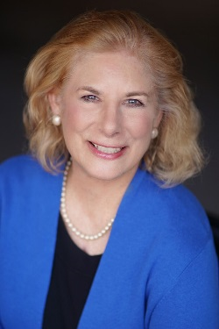

Murem Sharpe - Bio
With a career spanning over five decades, Murem Sharpe is a technology business founder and advisor, experienced Fortune 500 executive and former U.S. Senate staffer. Today she is Principal and Founder of StrategyRx, bringing breakthrough products and services in medicine and healthcare to market. She has pursued a successful career as a corporate executive managing product lines, business units, divisions and corporate functions that delivered valuable products and services to customers in industries including healthcare, financial services, technology, consumer products, automotive, and aerospace. Through her StrategyRx consultancy, for Micro C Imaging - a key client, she serves as Chief Marketing Officer. This innovative medical imaging company is poised to introduce the world’s first handheld fluoroscopy solution following upcoming 510(K) clearance by the FDA. For her high growth client companies she engages healthcare institutions and professionals, academic and scientific leaders, the media, and investors to meet business and financial objectives.

Murem’s volunteer leadership has paralleled her business career in length and accomplishment. Here are some examples. She currently serves as board vice president and mentor for the Creative Coast technology incubator. Trained as a WomenHeart Champion at the WomenHeart Science and Leadership Symposium Mayo Clinic in Rochester, Minnesota, she founded the WomenHeart community and patient support network in Savannah and serves as a WomenHeart healthcare legislative advocate. As an active alumni leader, Murem was elected a lifetime member of the Cornell University Council, having served as founding Vice Chair of the President’s Council of Cornell Women and Chair of the Advisory Council for Entrepreneurship at Cornell. Her career-long writing and speaking engagements include delivering a TED Talk at TEDxSavannah. While serving as an officer of the Hostess City Toastmasters - a President’s Distinguished Award Club, she has received the Toastmasters Gold Award by presenting scores of speeches on technical, business and civic topics.

Murem has lived and worked in Washington, DC, New York City, Washington, DC, Stamford, CT, Barcelona, Spain, and Bloomfield Hills MI and has traveled in Europe, Africa, South America, and Asia. She currently lives in Savannah, Georgia with husband, Tom Sharpe, a business owner, whom she met while they were students at Cornell University. He also holds and M.B.A. from the Wharton School of Finance. Their adult children, Emily and Eric, live and work in London and Atlanta,

