2018 Atlantis Casino Spa – Reno, NV
COMPANY | SPONSORSIP LEVEL | EVENT OR ITEM
 | Platinum | Feature Event National Automobile Museum
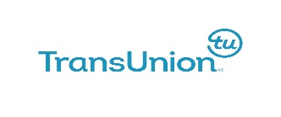 | Gold | Keynote Speaker  Scott Bolzan
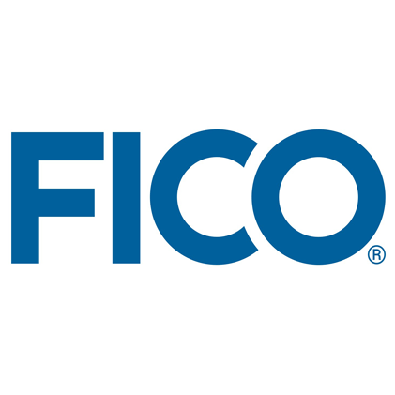 | Gold | Welcome Reception  & Marketplace
 | Gold | Master of Ceremony  Connie Wray
 | Silver | Sharper Lending  Welcome Bags
 | Silver | CreditXpert  Conference Lanyards
 | Silver | Room Keys
 | Silver | Wednesday PM Break
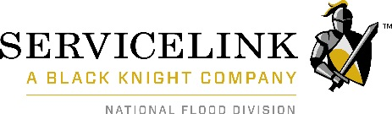 | Silver | Footstep Clings
 | Silver | Wednesday Lunch
 | Silver | Wednesday Breakfast
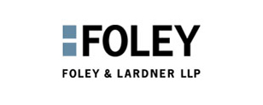 | Silver | Thursday Breakfast
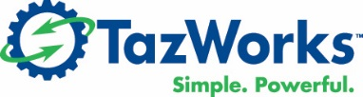 | Bronze | Wednesday AM Break
 | Bronze | Thursday AM Break
 | Bronze | Thursday PM Break

